Om Sri Sairam
Please find instructions of how to log into the website srisathyasaipremataru.org.

- On any web browser, go to https://sssprematharu.org

- On the page that appears, click on the 3 horizontal lines at the top, right hand corner.
2.
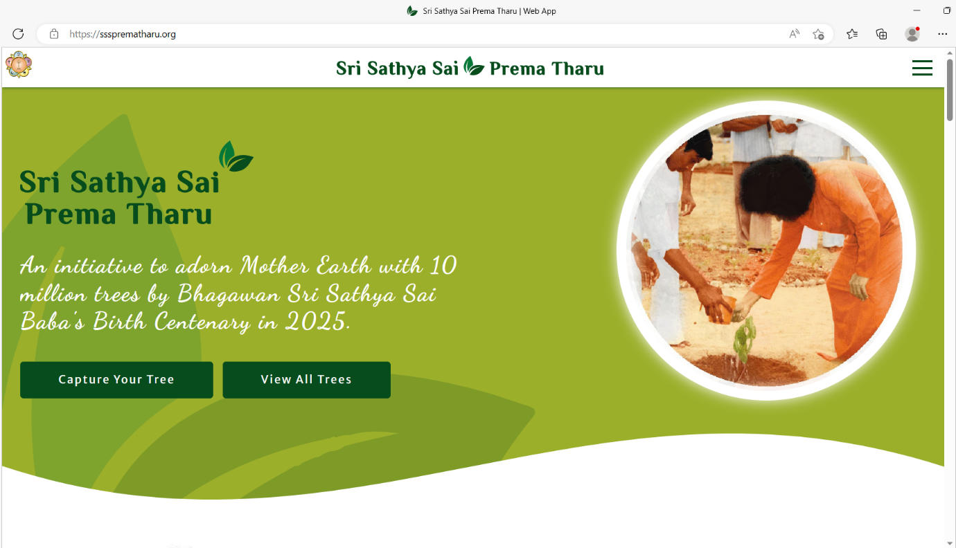

3. The following screen will appear, with the Login option on the top right-hand corner as shown below.

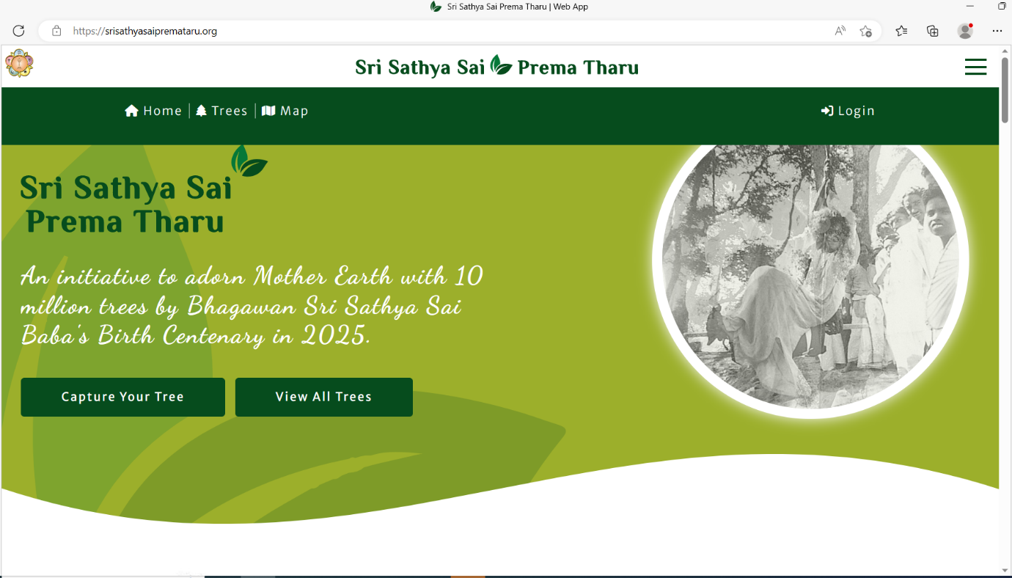
3.

4. Click on the Login as shown in figure 3 and then the following dialogue box will appear.
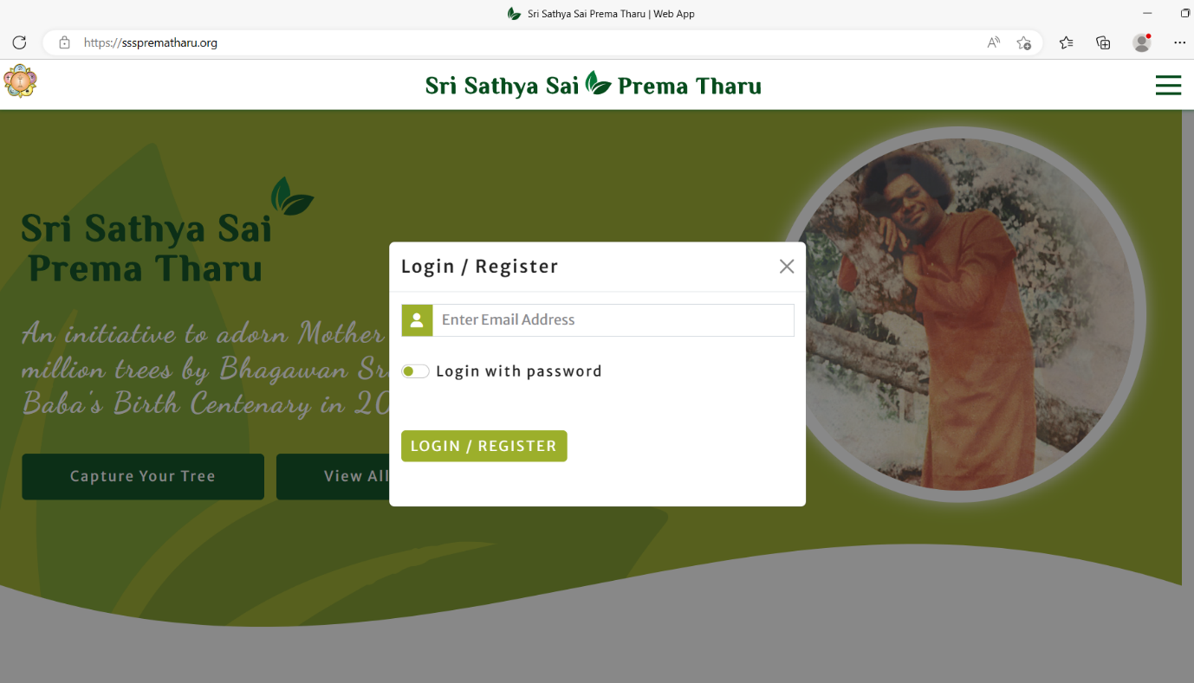

5. Enter your E-mail ID as shown below and then click Login / Register.
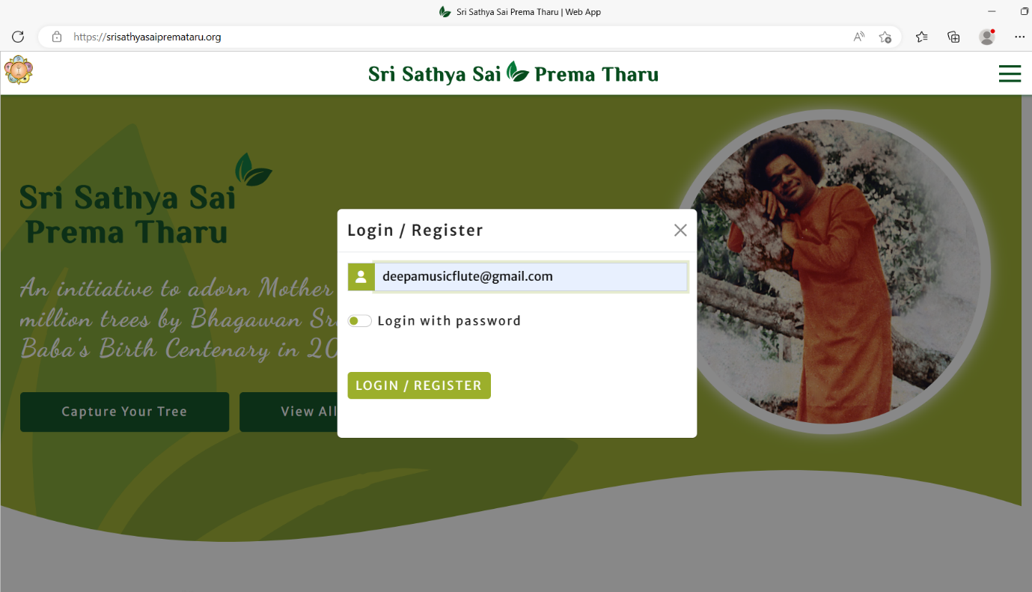
6. Then as shown below you will be asked to check your mail’s inbox / spam folder.
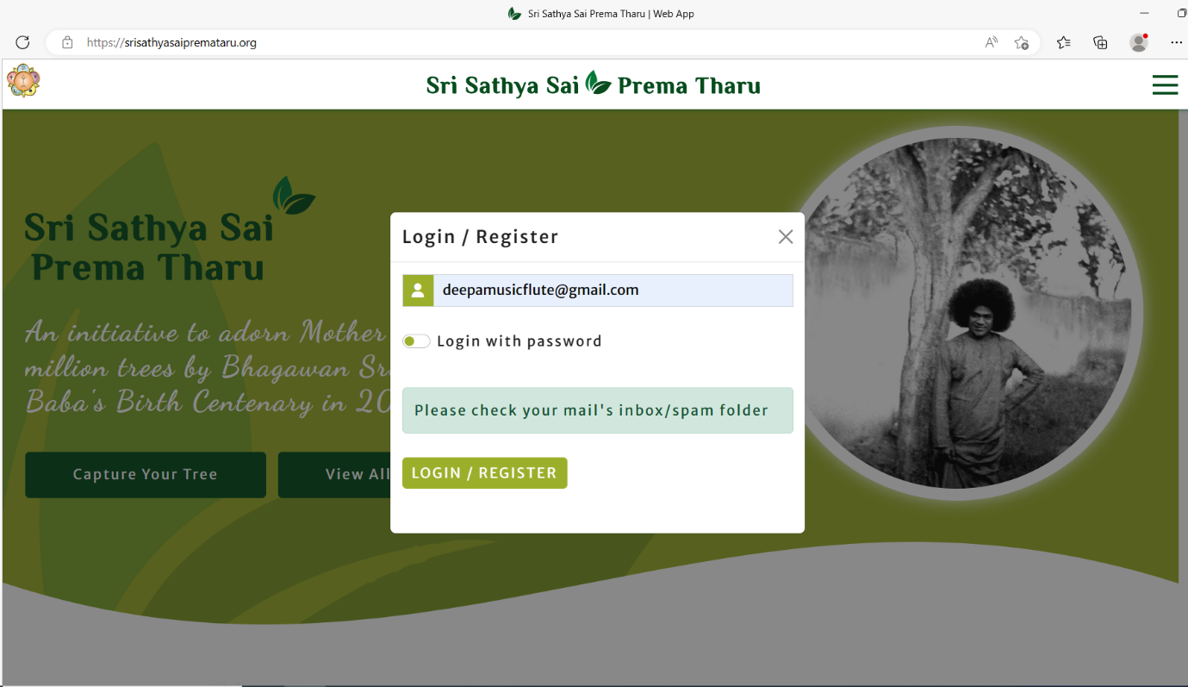

7. You will receive an email like the one shown below.
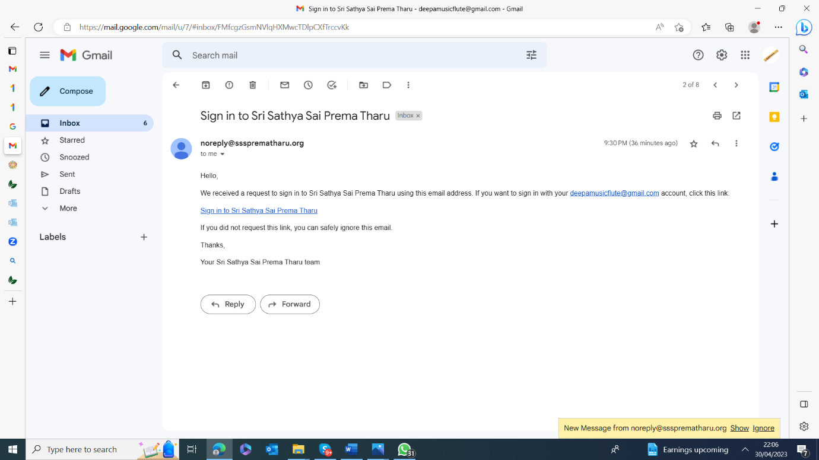

8. By clicking on the link Sign in to Sri Sathya Sai Prema Tharu in the Email, you will be able to see a screen similar to the one shown below.

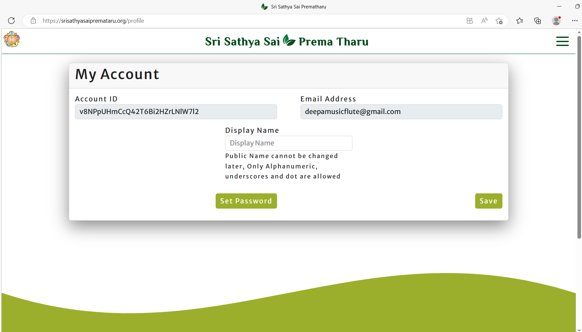

9. Choose a Display name that you wish and click on the Save button.
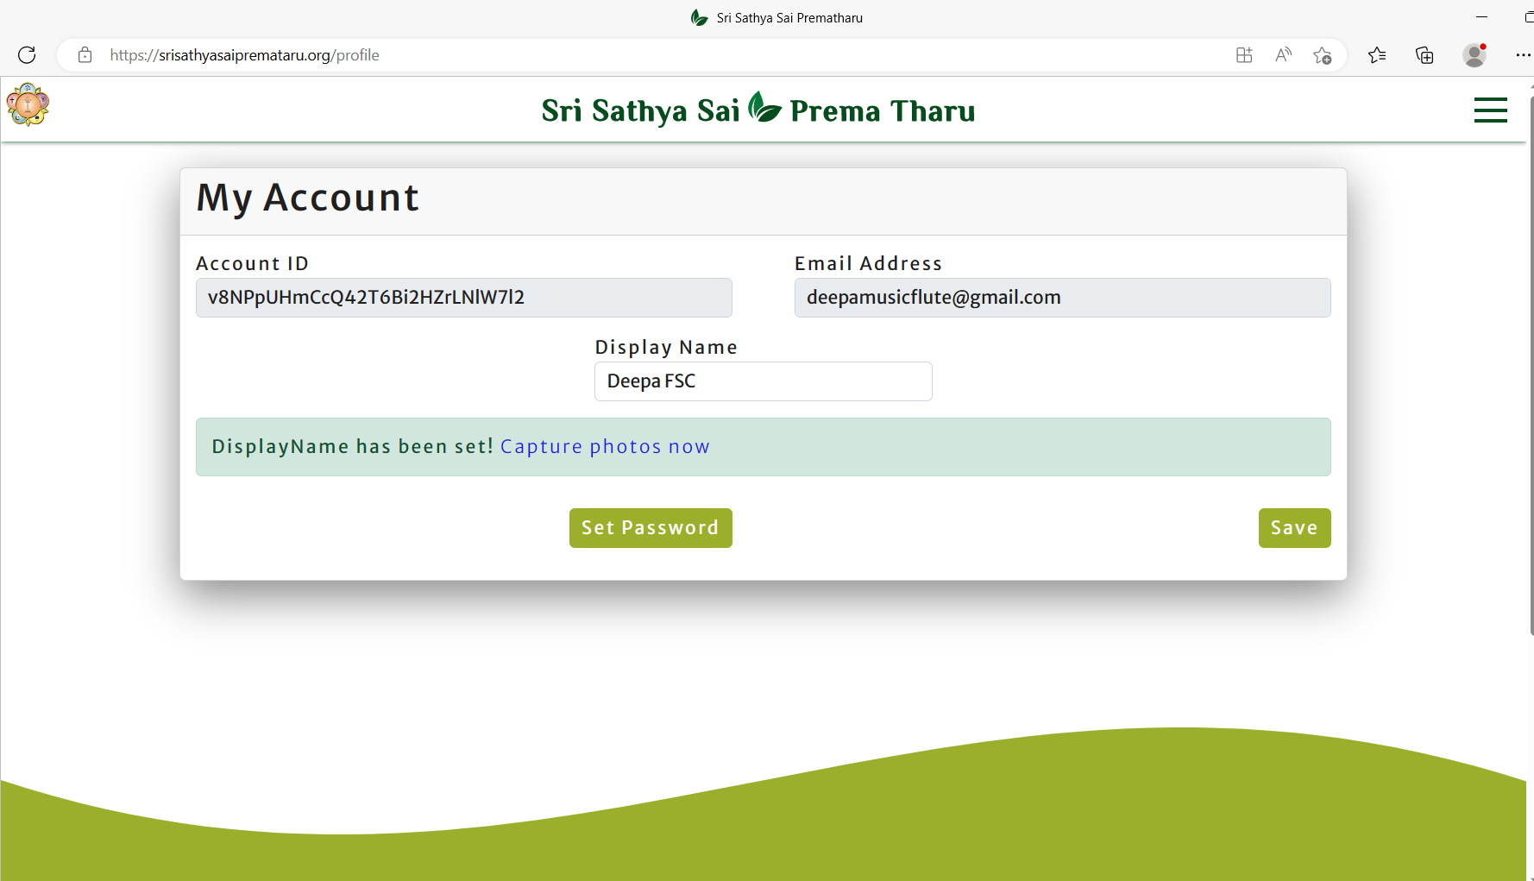

10. Now click on Set Password. A dialogue box will appear saying that “Reset link sent to your registered email address”.
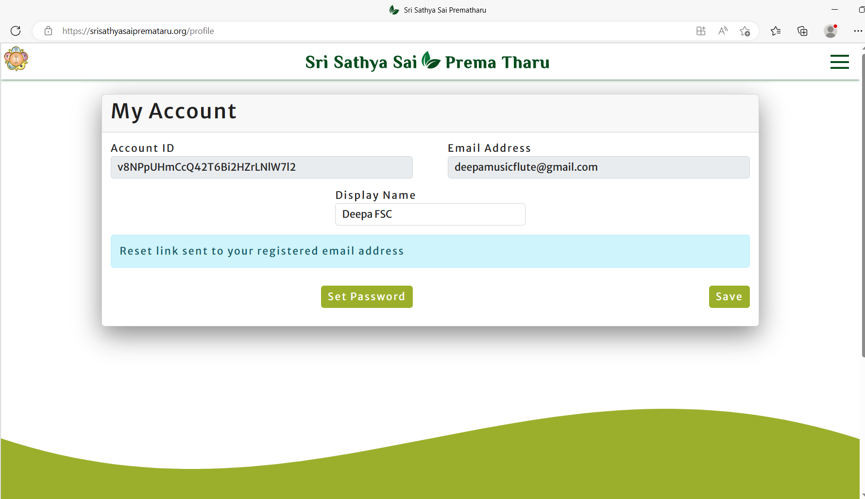

11. You will receive another link to your registered email address.
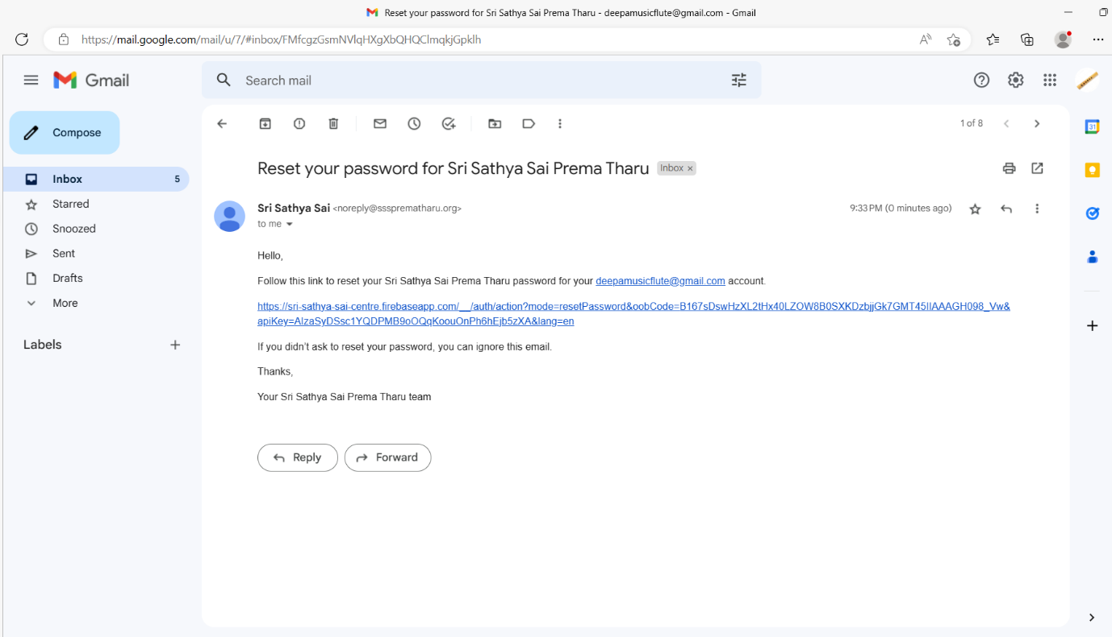

12. By clicking on the link which was sent to your registered email, you will be directed to Reset your password as shown below.
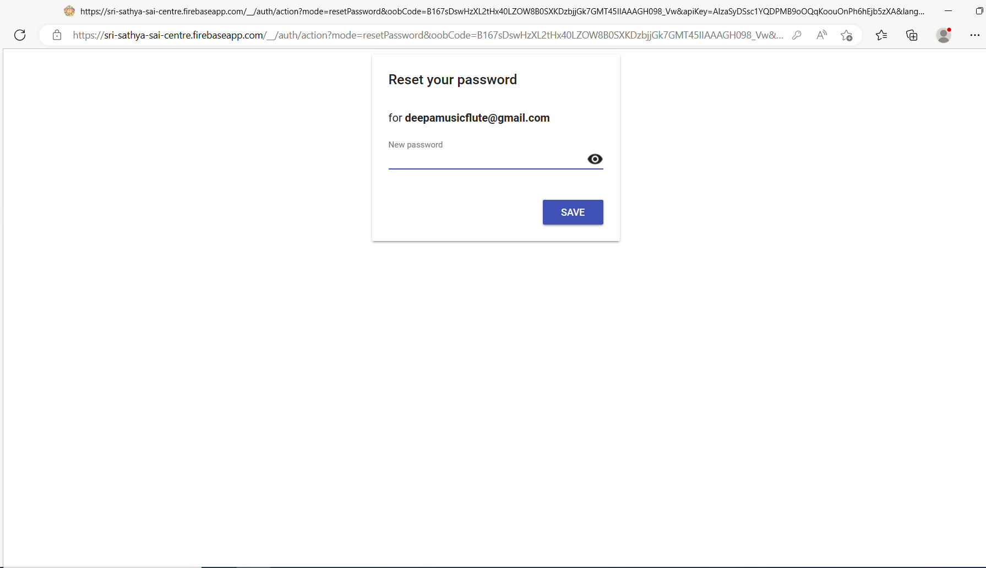

13. By entering a new password, you are set to use the website/ capture photos and upload them.
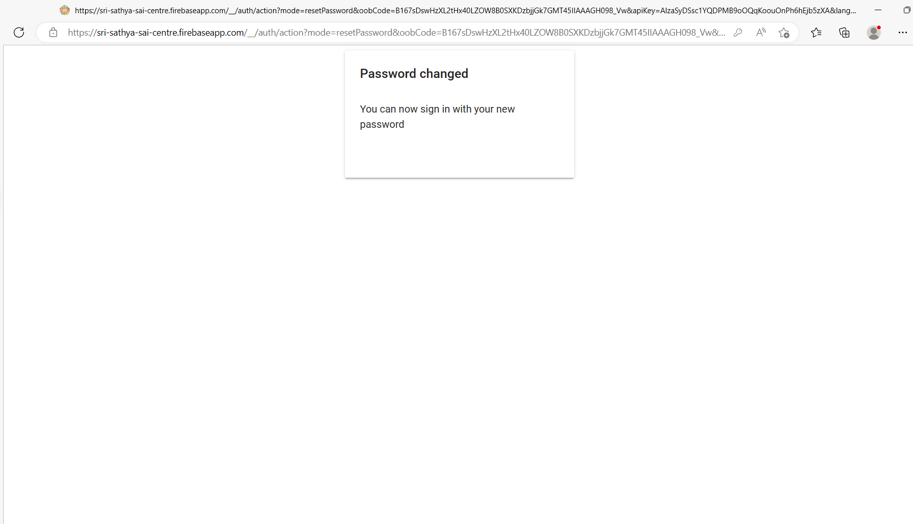

14. Once you are registered, to log back in again, you need to toggle the button which says “Login with Password” as shown below and enter your password which you had already set.
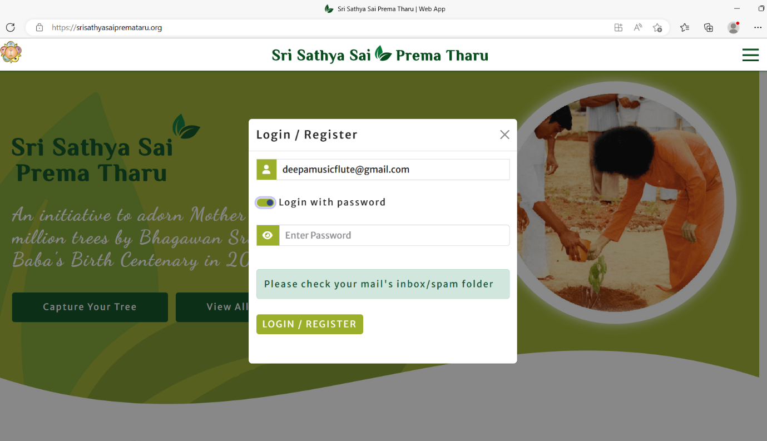
This is the toggle button

If you have any issues logging to the website, please contact your centre service co-ordinator or youth co-ordinator.

